Geographic Information System

Midterm GIS Project

5000 Evler Neighborhood - KARABUK

horizontal line

# Placeholder image

# Introduction

In this project we managed to follow four main steps:

1. Define the objective
2. Data collection
3. Data analysis
4. Data presentation

## 

## Project report

In the first step after defining the objectives we started to collect the data as follows:

* Cutting the border for the working area that we need using **Google earth pro**

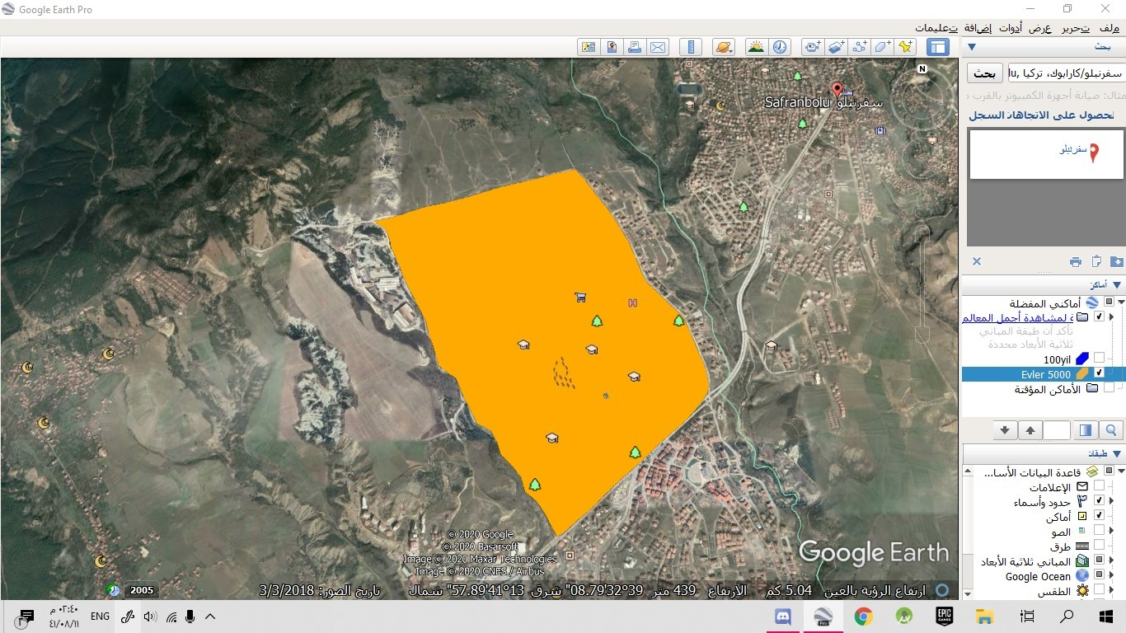

* Importing the data that we got into the **ArcMap** app

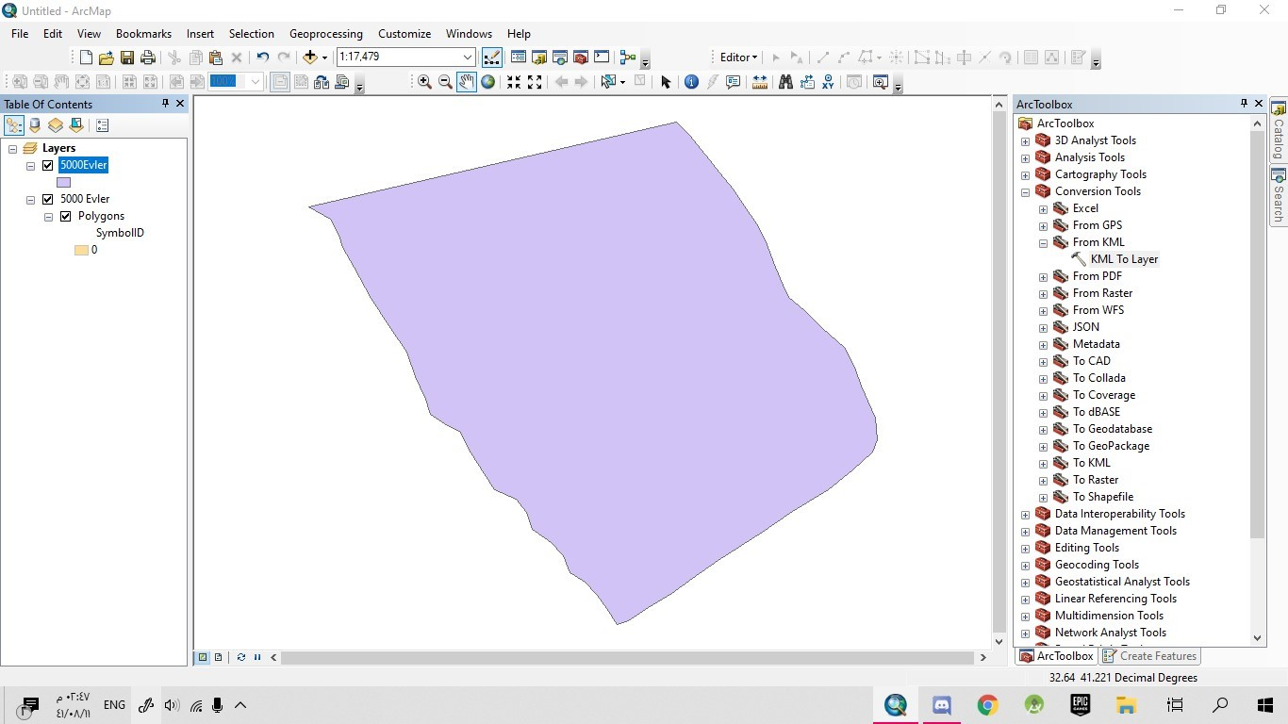

* Importing the satellite image into ArcGIS using SasPLanet

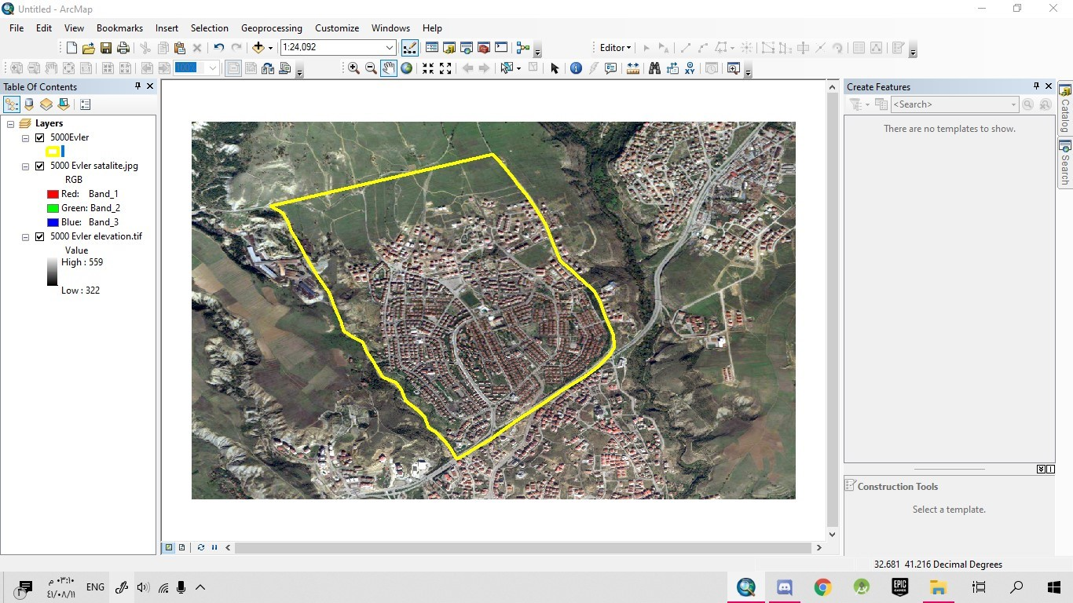

* Converting all layers to **WGS_1984_UTM_Zone_36N** coordinate system and creating the four demanded layers

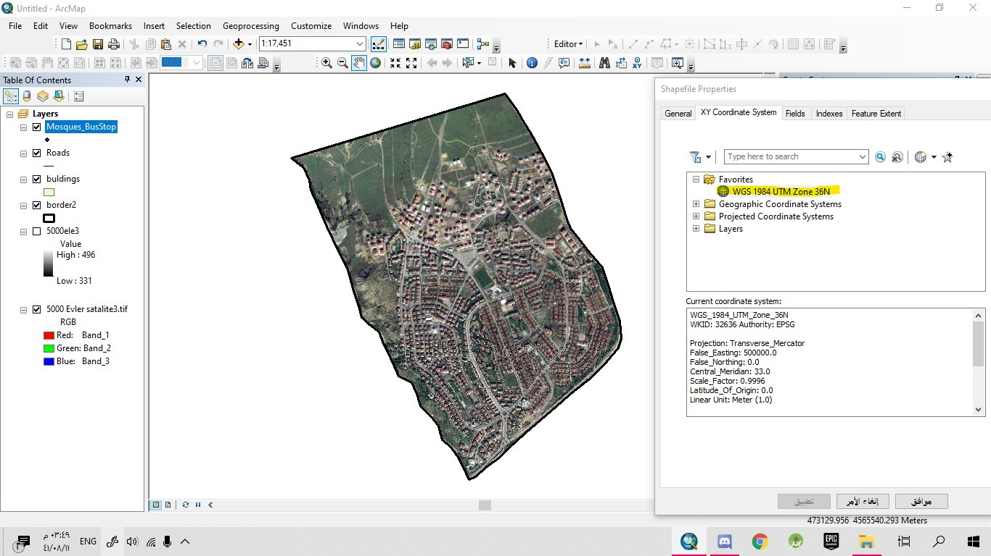

* Creating the building layer

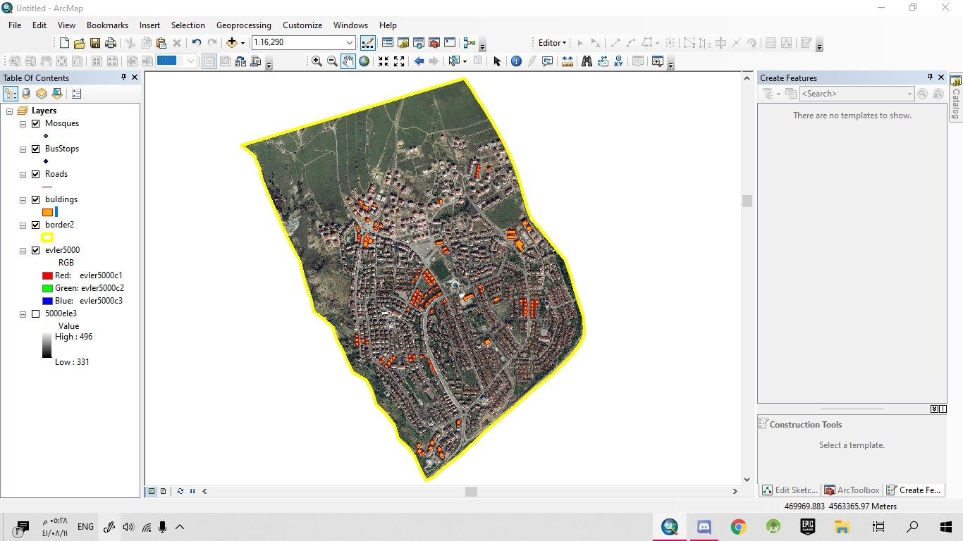

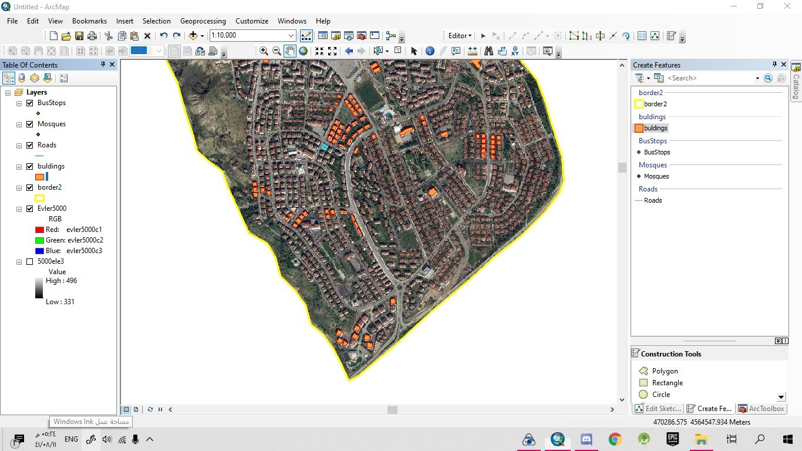

* Creating the Roads layer

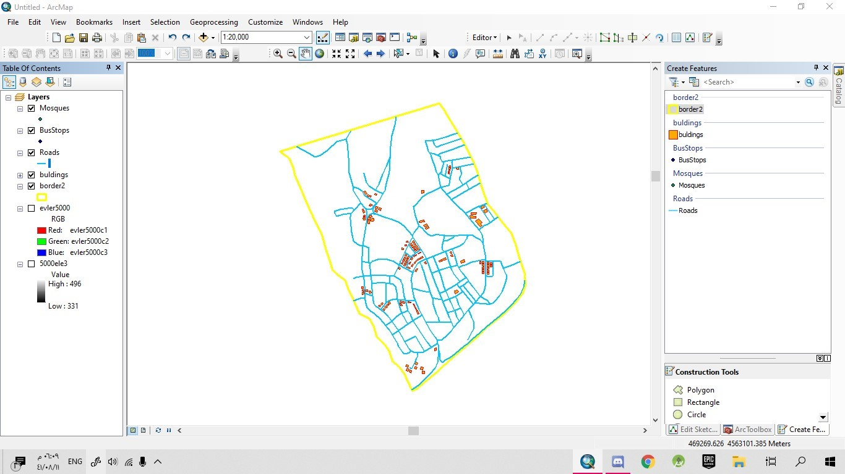

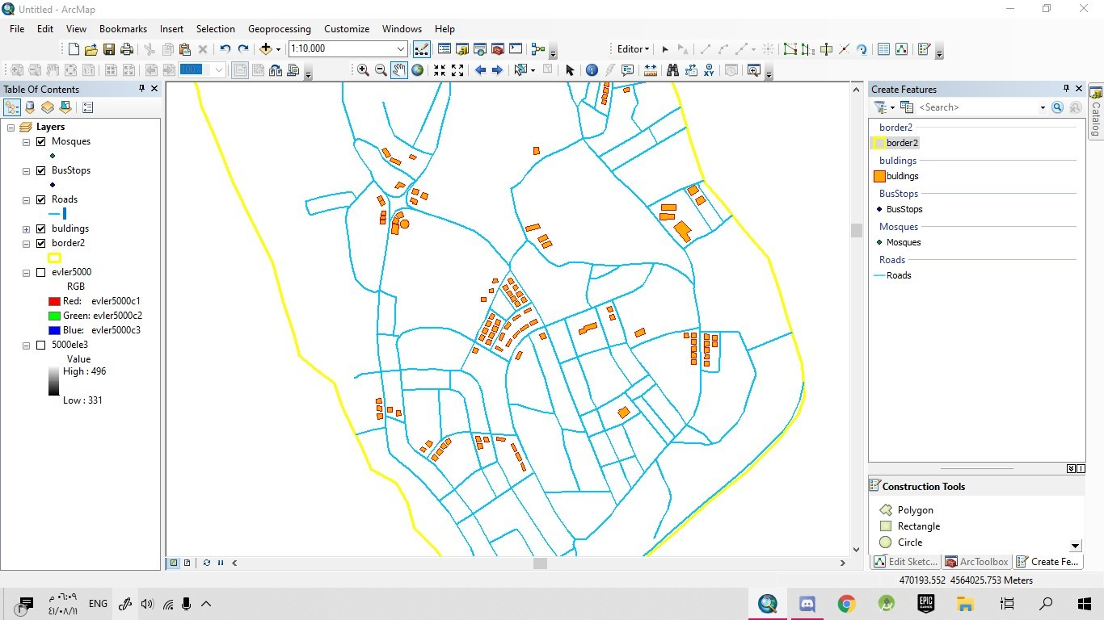

All the layers including mosques and bus stops

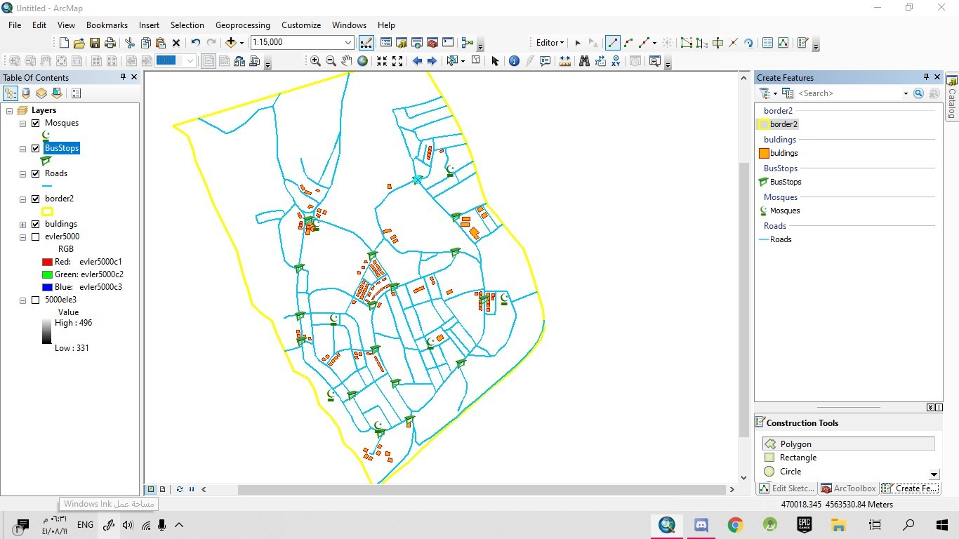

**5.a)** Number of buildings that their area is more than 100 m square

Note: all our buildings are more than 100m square as you can see

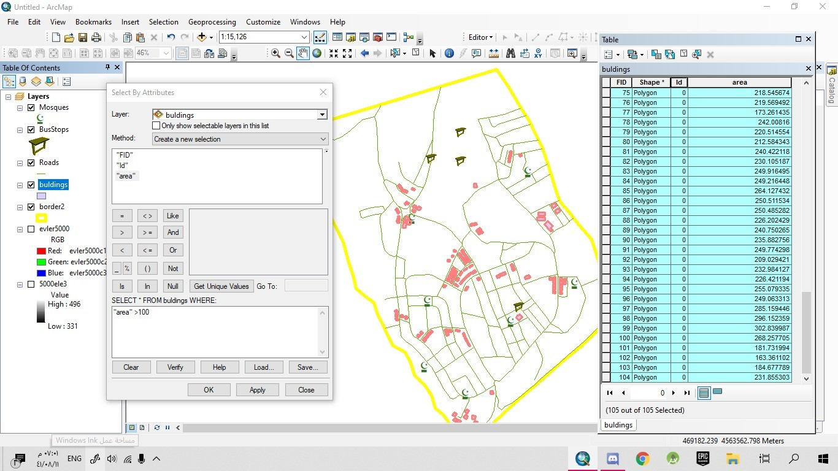

**5.b)** The area of the map project that we create

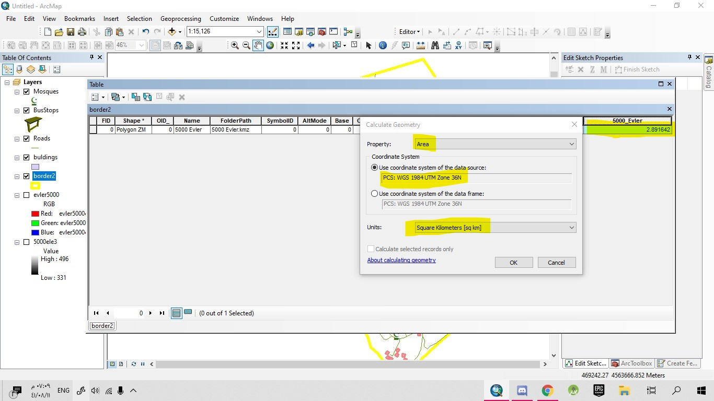

**5.c)** the total length of the roads

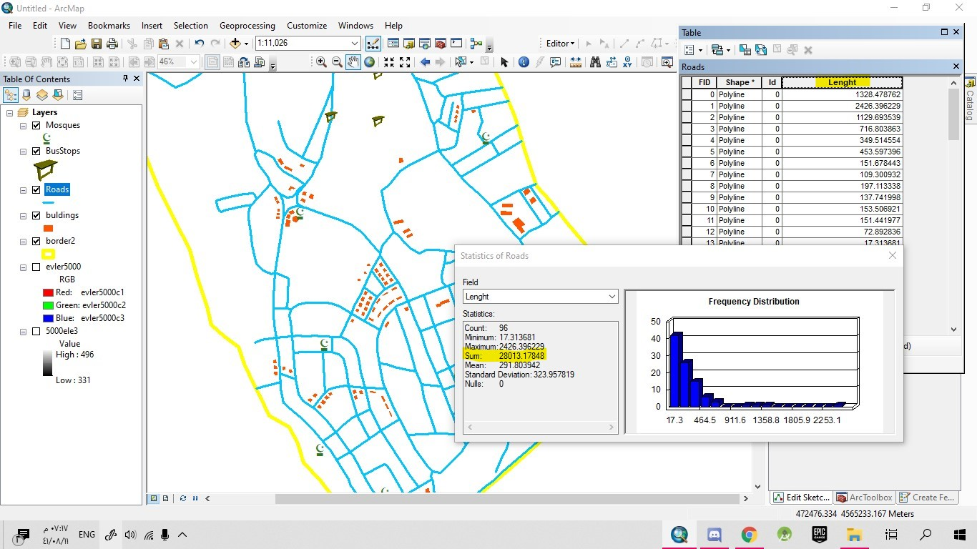

**5.d)** the total area of the buildings

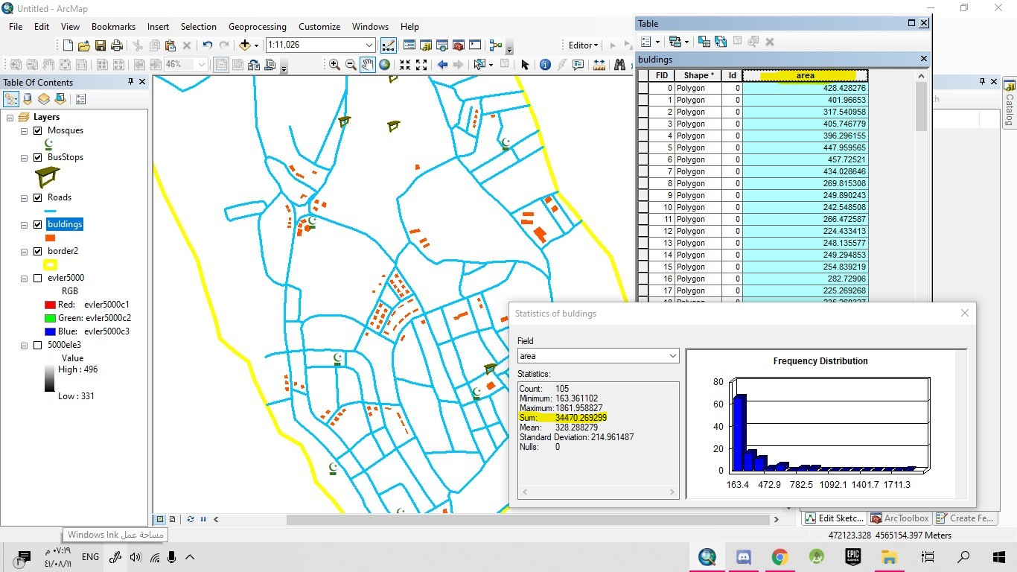

**5.e)** the centroid of the neighborhood

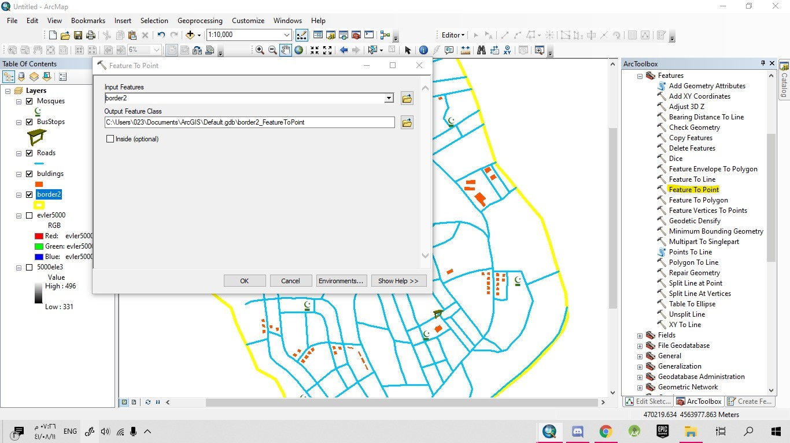

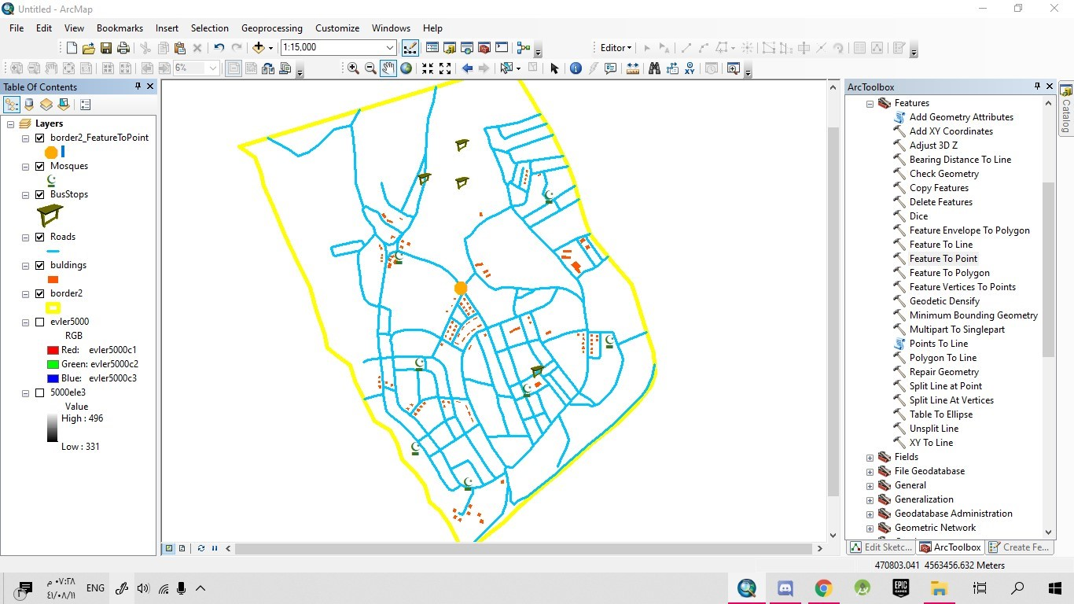

**5.f)** Highest and lowest elevation

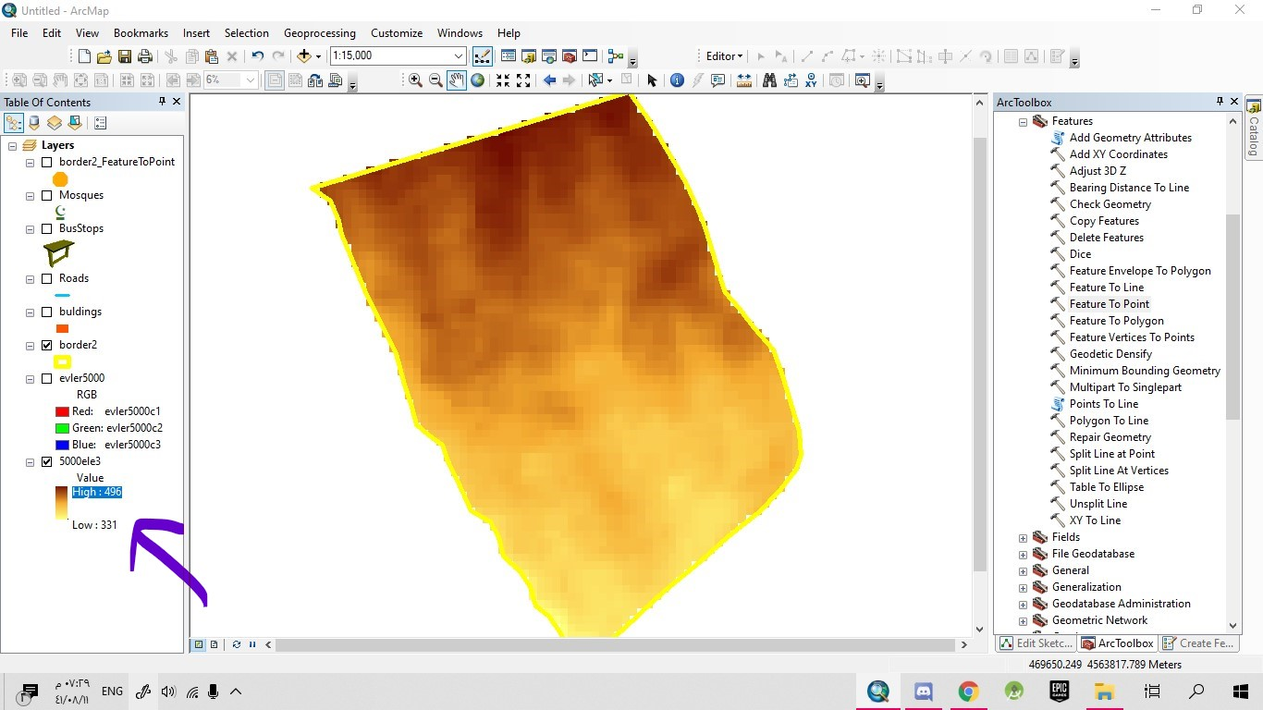

**5.g)** The centroid of the biggest three buildings

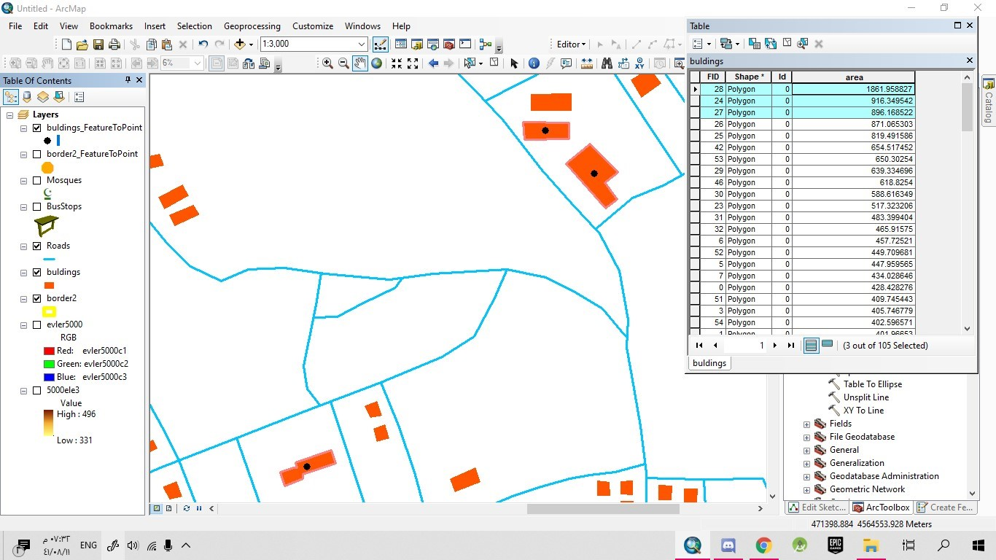

**5.h)** Building within 300 meters from the main bus stop

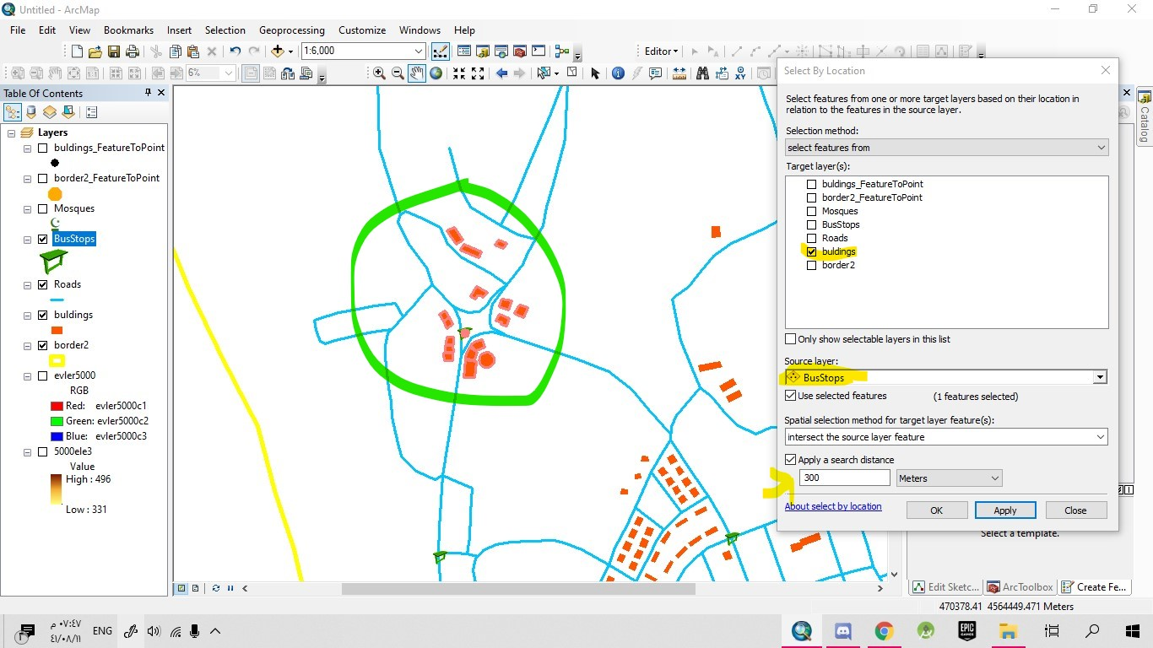

**5.i)** The shortest way between the main bus stop and any building

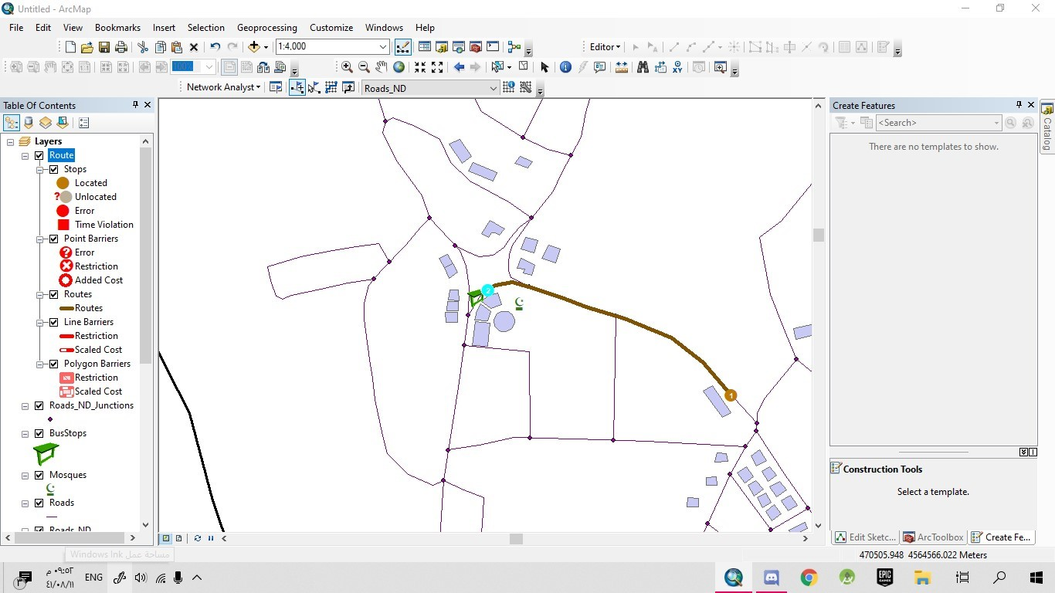

**6.a)** buildings with their label (area)

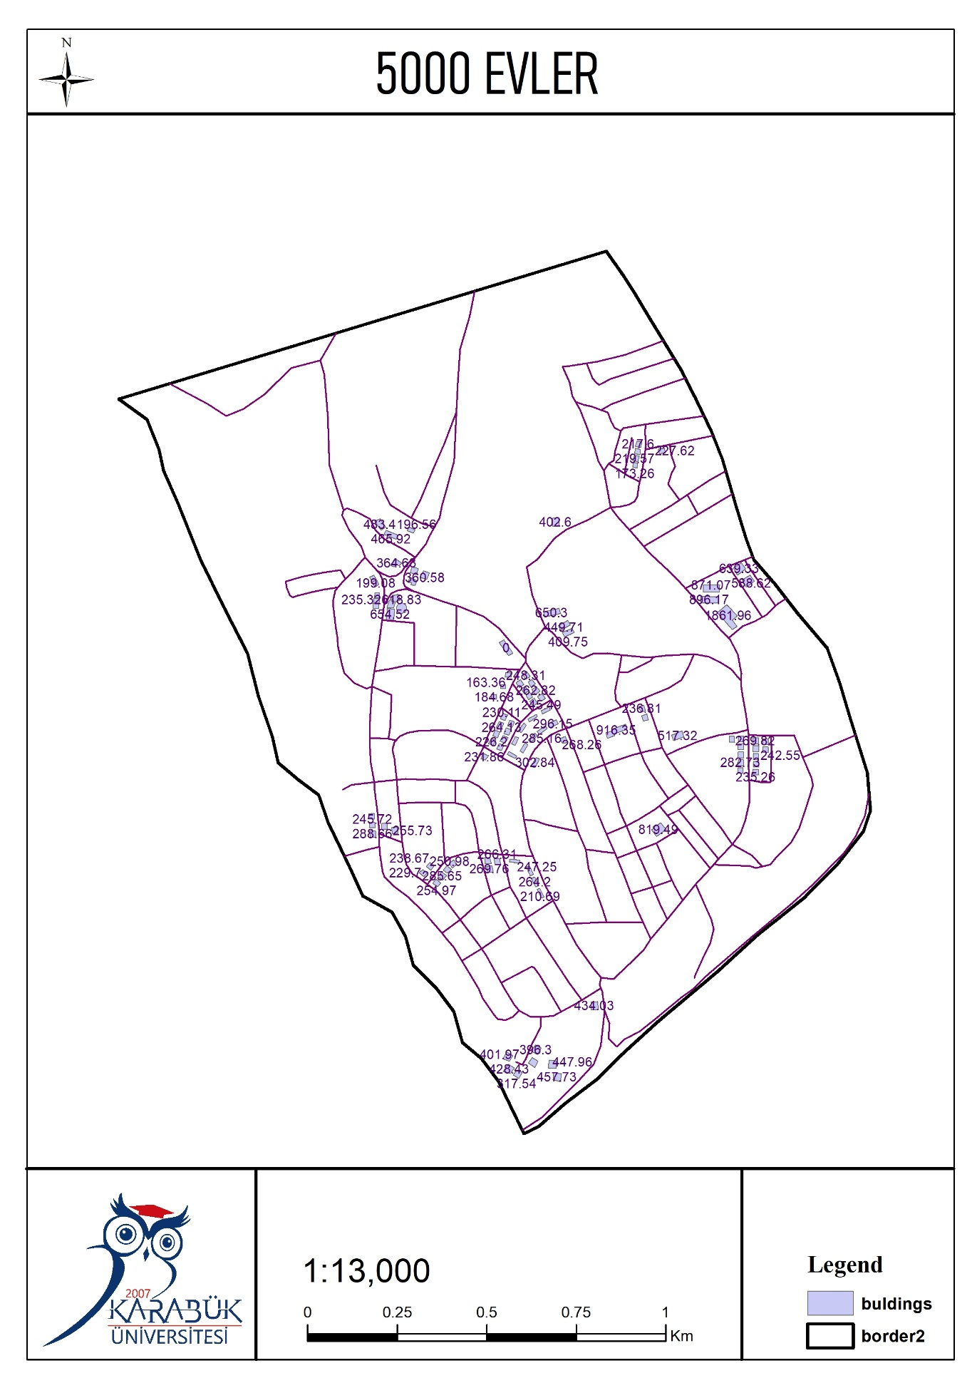

**6.b)** Coloring the buildings based on their area

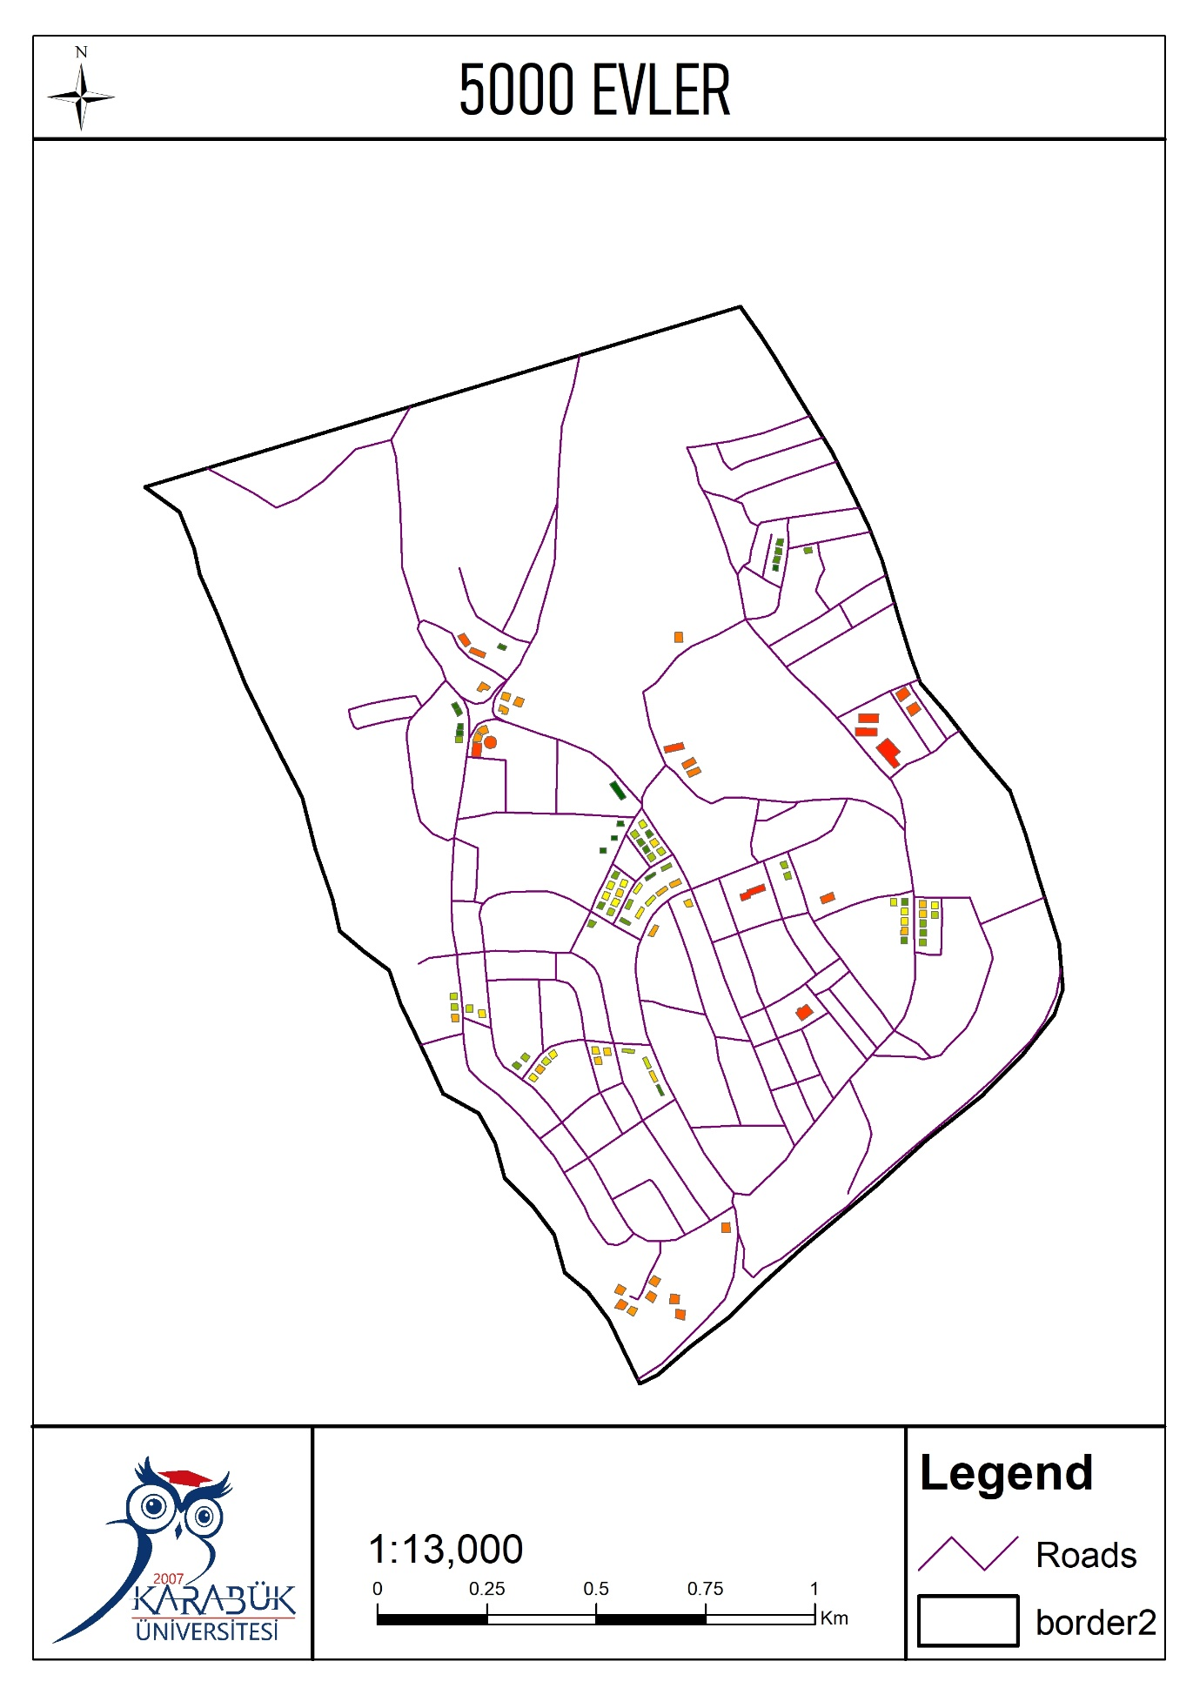

**6.c)** Roads layout

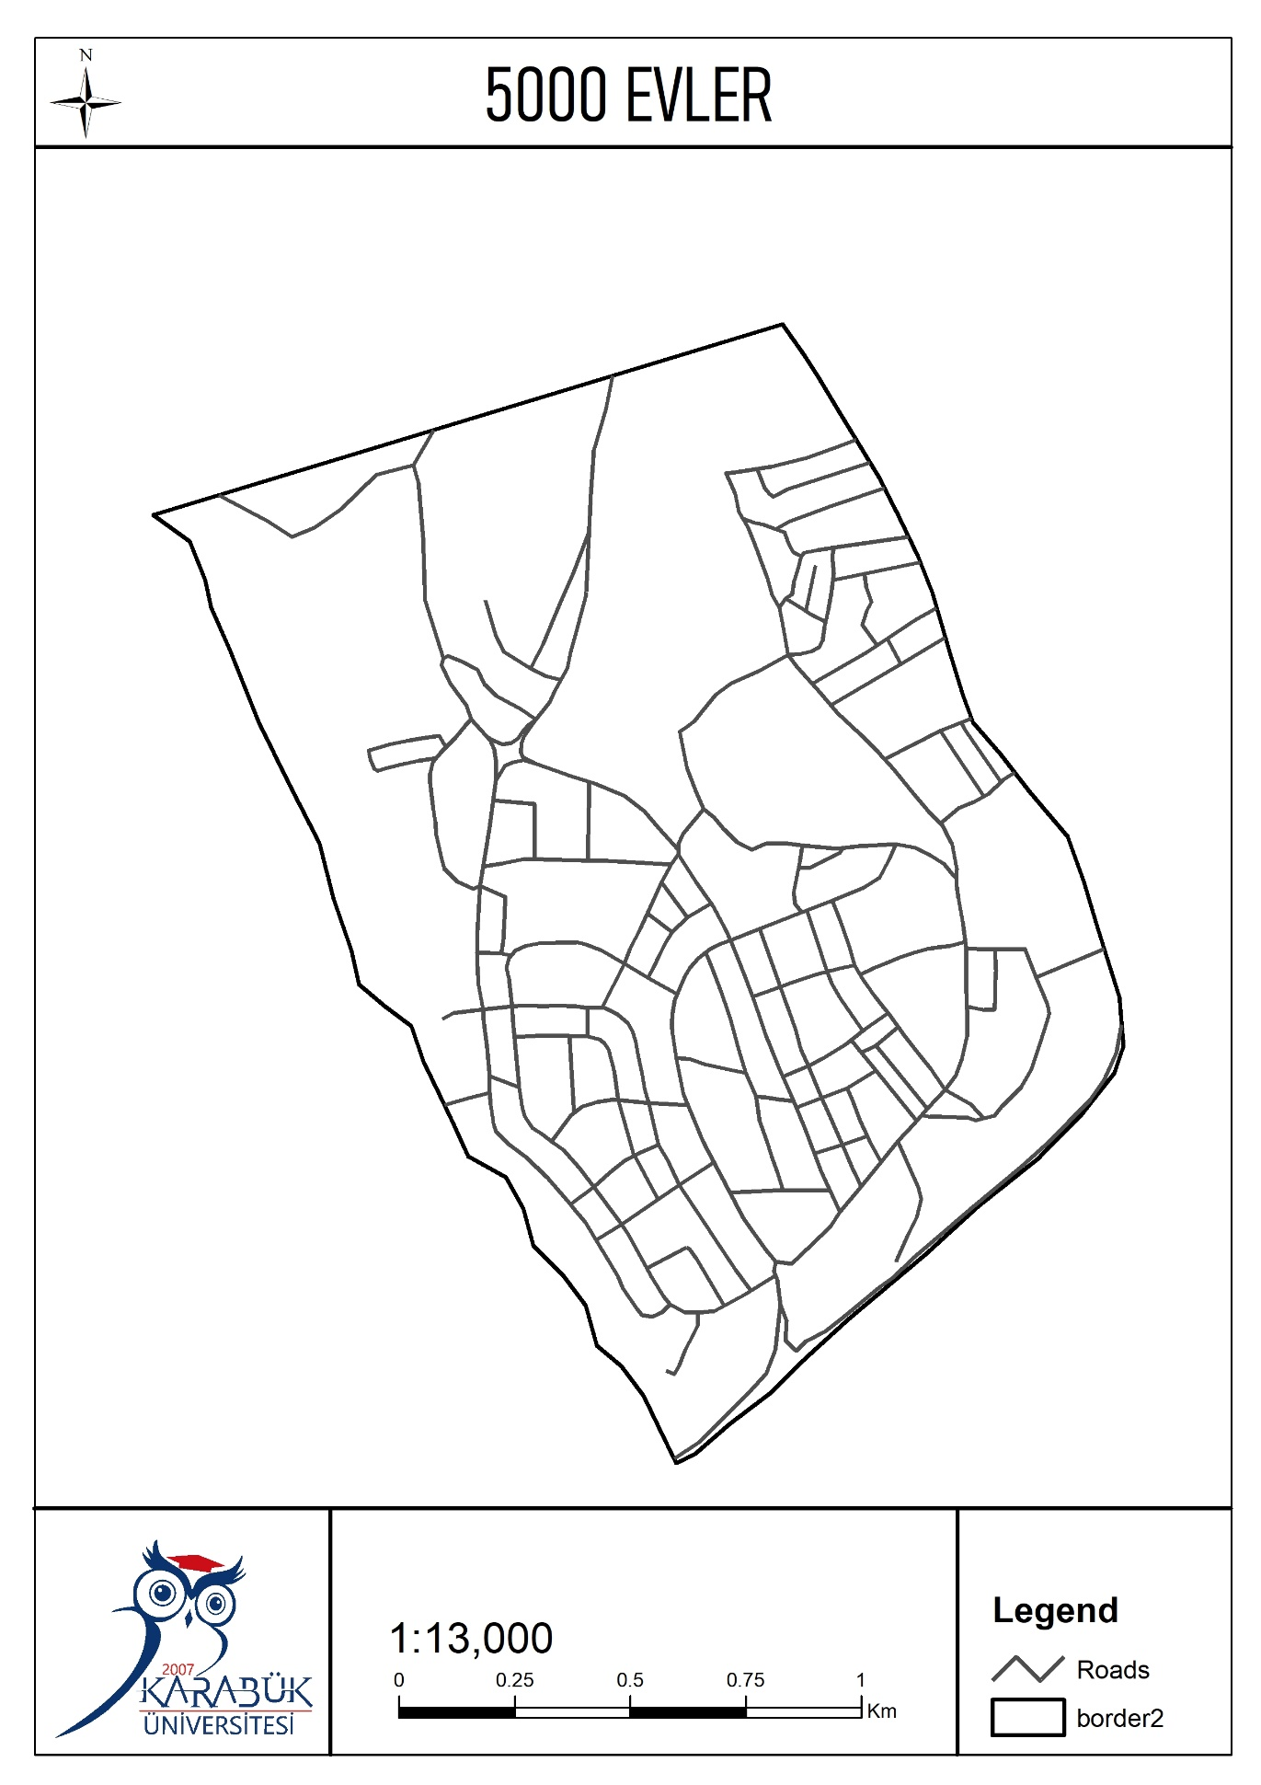

**6.d)** Elevation Layout

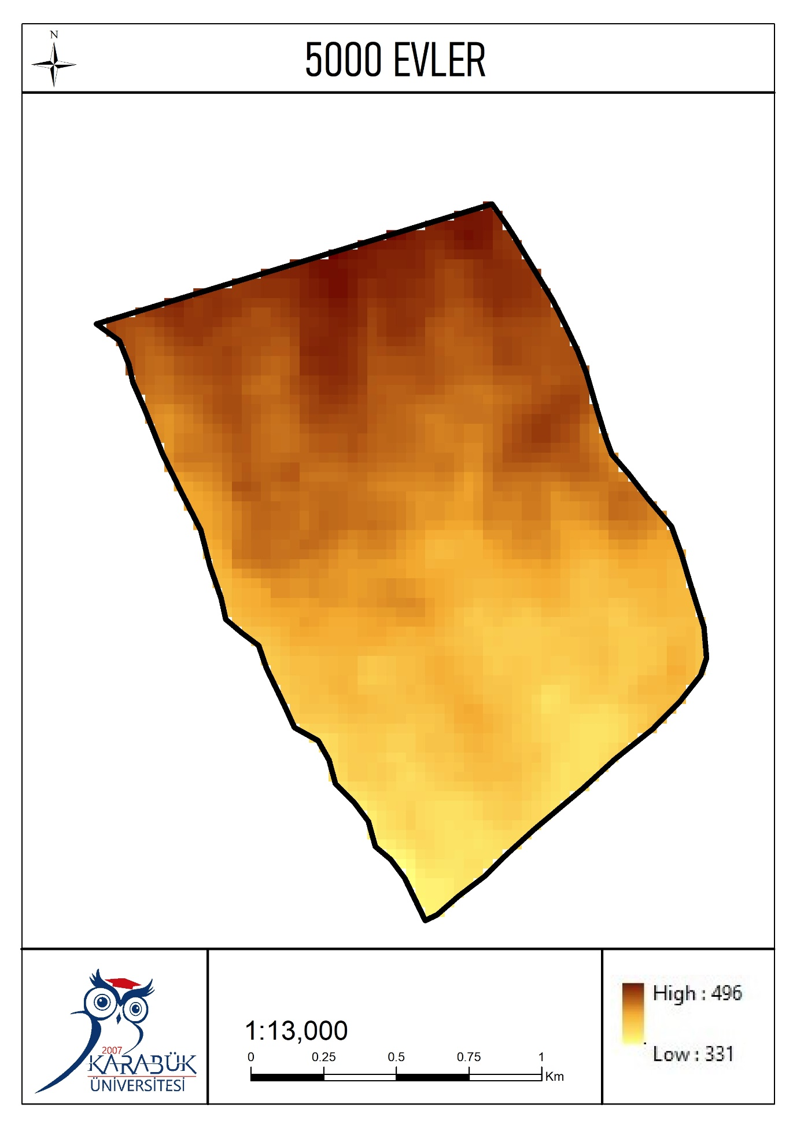

**6.e)** Bus Stops and Mosques layout

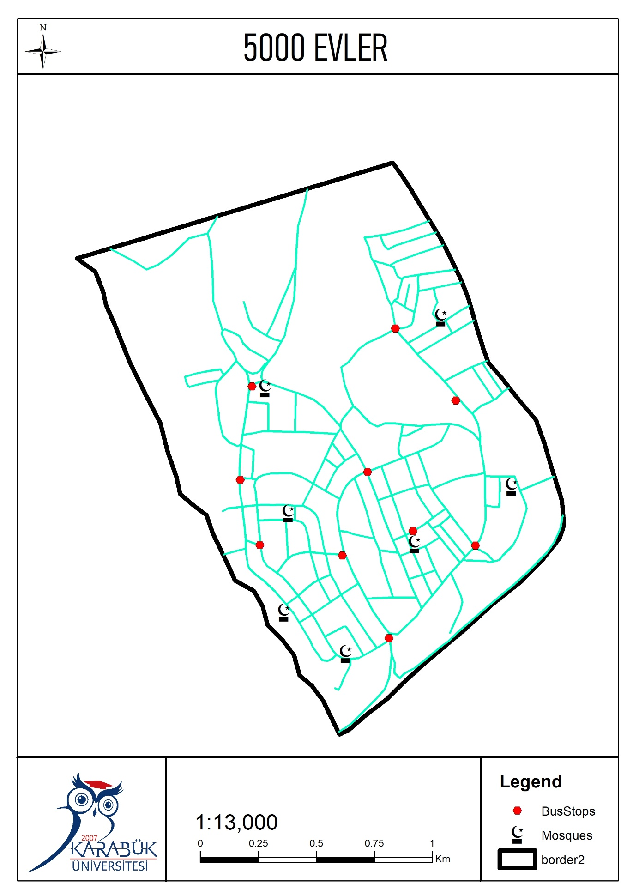

**6.f)** Satellite Image

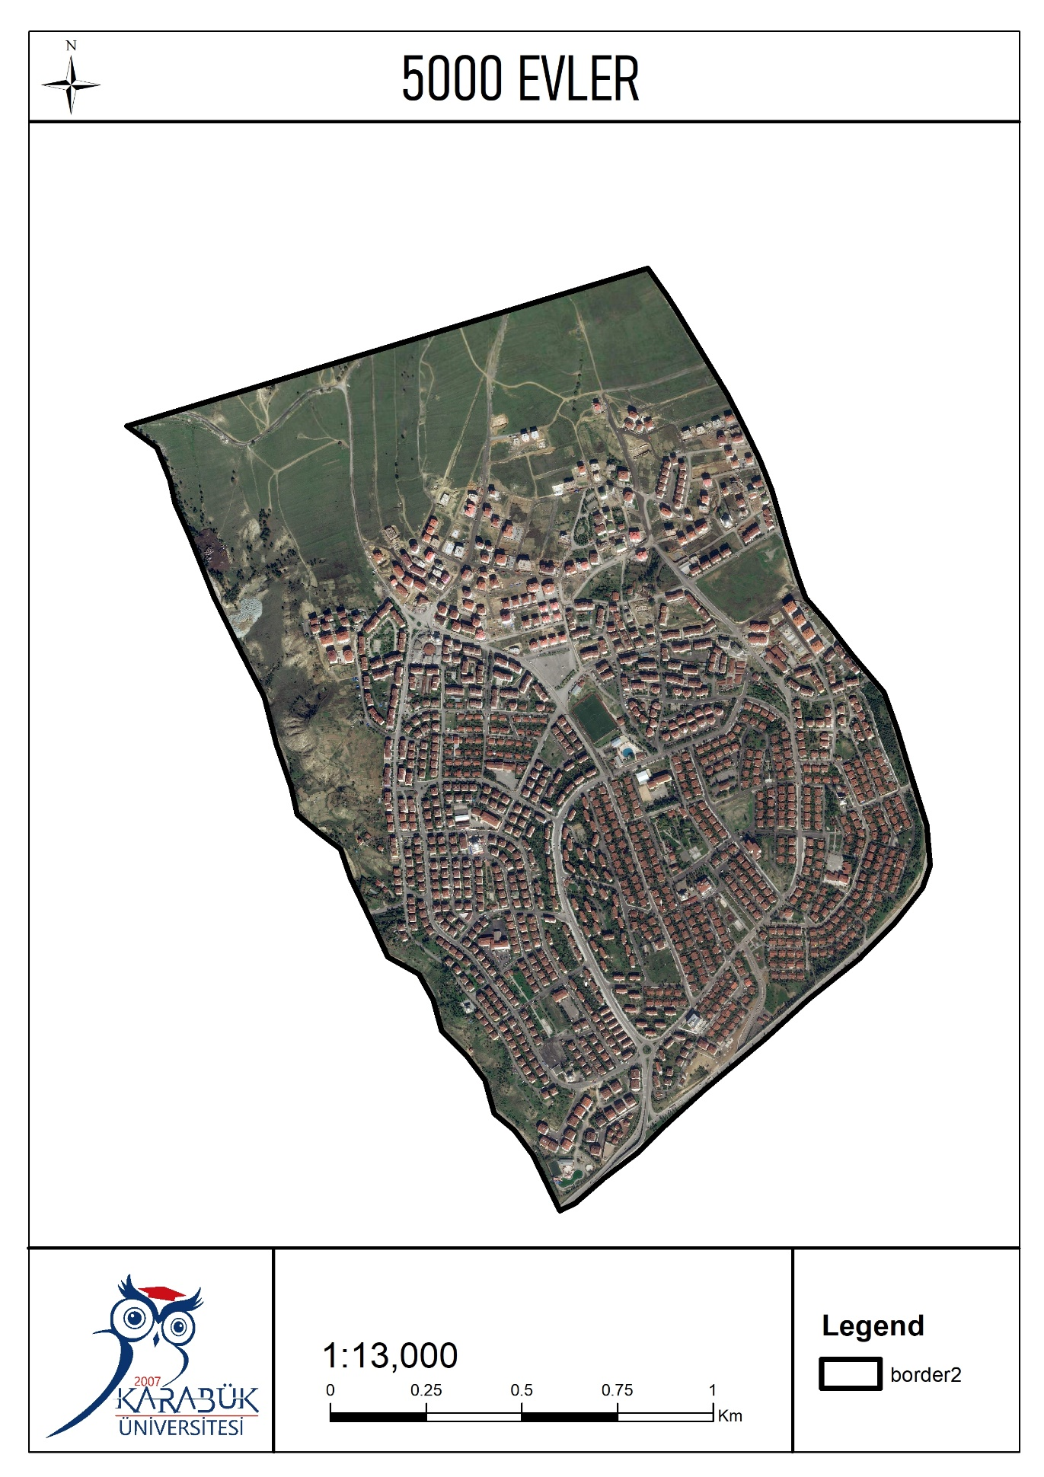

KARABUK UNIVERSITY

Engineering Faculty

Computer Engineering Department

Geographic Information System Course

horizontal line

Prepared By:

Bashar KHATIB STD NO: 2015710213101

Abdullah HABLAS STD NO: 2015710213001

Asil ÇORBACI STD NO: 2015710213008

Abdulaziz DAMLAHI STD NO: 2015710213037

Project Supervisor:

Dr. Sohaib ABUJAYYAB